***Comforty: Revolutionizing***



C

O

M

F

O

R

T

Y

:

R

E

V

O

L

U

T

I

O

N

I

Z

I

N

G

F

U

R

N

I

T

U

R

E

E

-

C

O

M

M

E

R

C

E

T

r

a

n

s

f

o

r

m

i

n

g

O

n

l

i

n

e

S

h

o

p

p

i

n

g

w

i

t

h

S

e

a

m

l

e

s

s

M

a

n

a

g

e

m

e

n

t

a

n

d

U

s

e

r

-

F

r

i

e

n

d

l

y

F

e

a

t

u

r

e

s

***Furniture E-Commerce for Easy***

***Management and Seamless Shopping***

**Introducing Comforty**

Welcome to Comforty, where we are transforming the way you shop for furniture online. Our platform is designed to provide a seamless and intuitive shopping experience, making it easier than ever to find and purchase the perfect pieces for your home or once. We focus on easy order management and user-friendly navigation to enhance your e-commerce journey.

# The Challenges in the Furniture E-Commerce Industry

The online furniture shopping experience comes with its own set of challenges. Customers often encounter:

Limited product details

Poor website navigation

Di fficulties in managing and tracking orders

These issues can lead to frustration and a subpar shopping experience i solve in this website .

# Comforty Solution to Simplify Furniture Shopping

**Content:**

Comforty addresses these challenges head-on with:

Dynamic product pages featuring comprehensive details

Intuitive category search functionality

A user-friendly order management system powered by Sanity

Our platform is designed to provide a smooth, hassle-free shopping experience.

**Dynamic Page and Order managment Images**

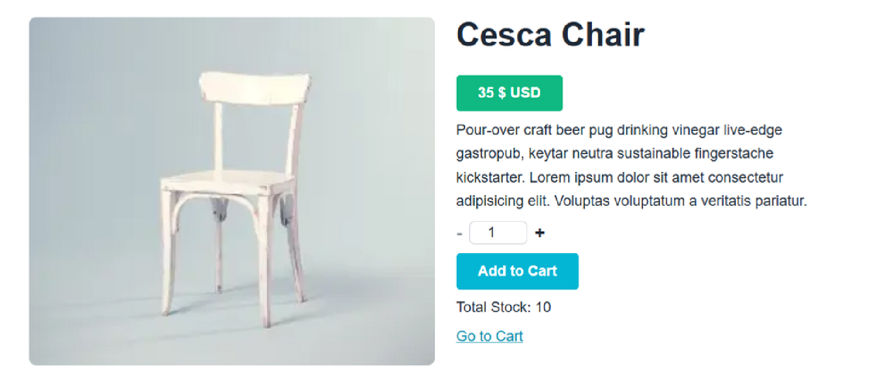

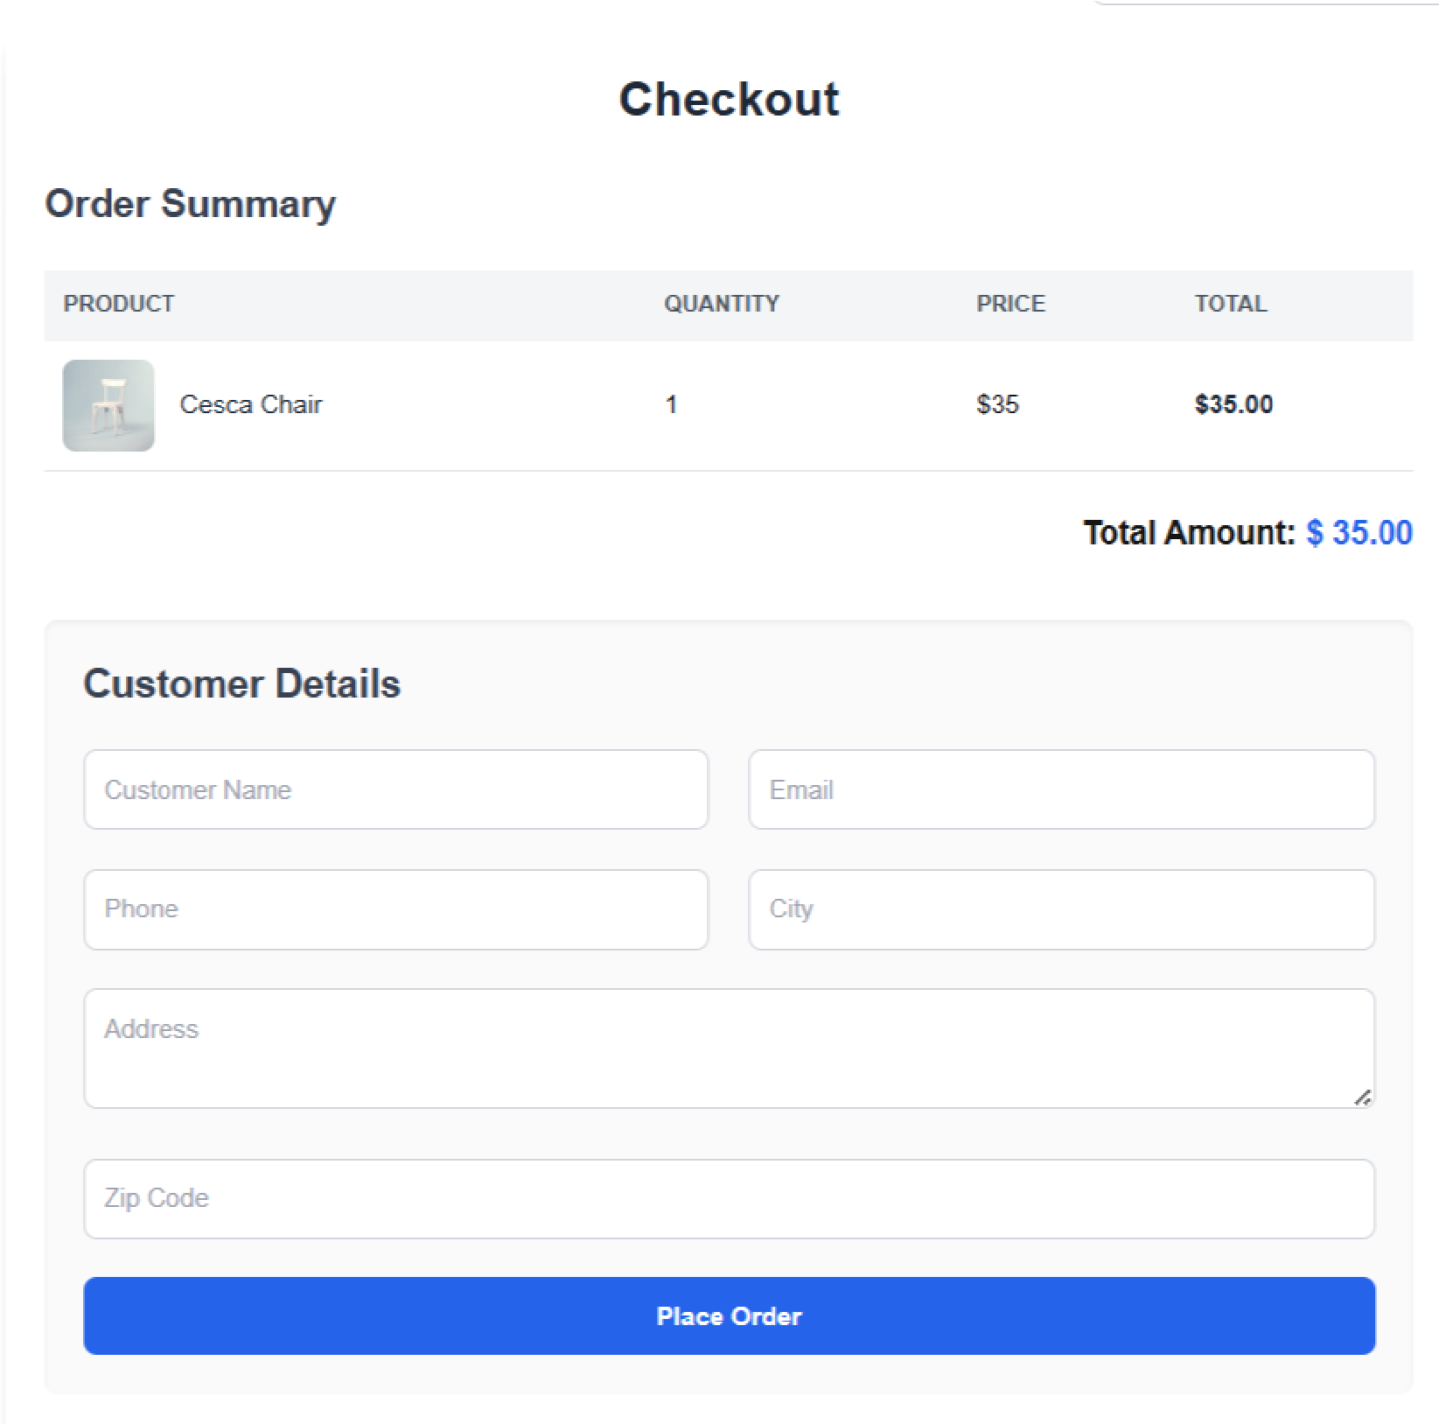

## Key Features of Comforty

Our website is packed with features to enhance your shopping experience:

Responsive design for all devices

Add to cart and seamless checkout functionality

Dynamic product details page

Advanced category search and filter options

User order management integrated with Sanity

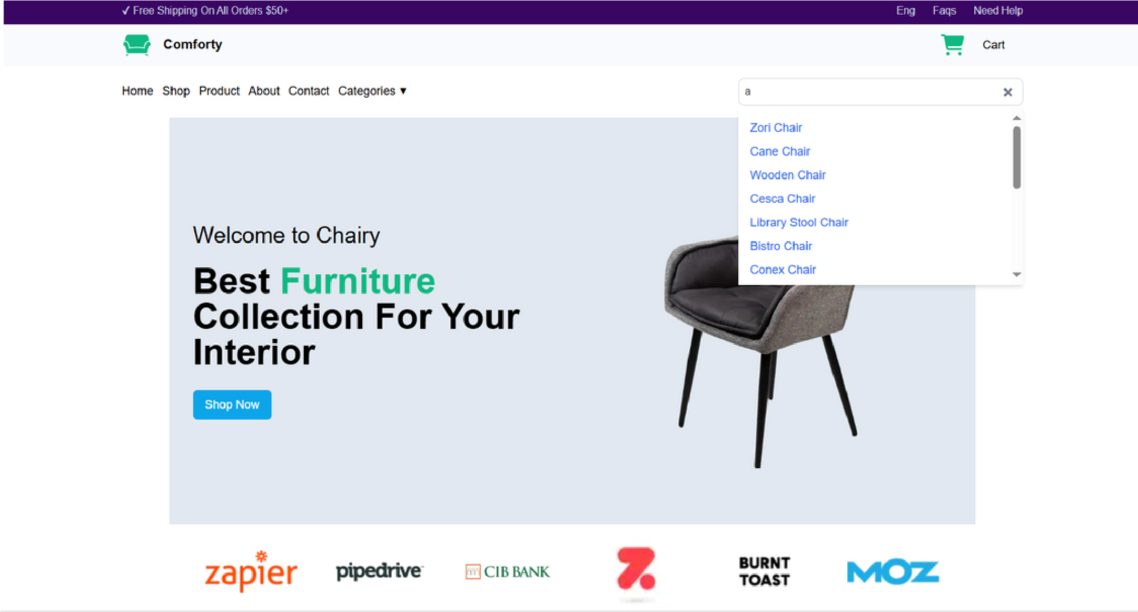

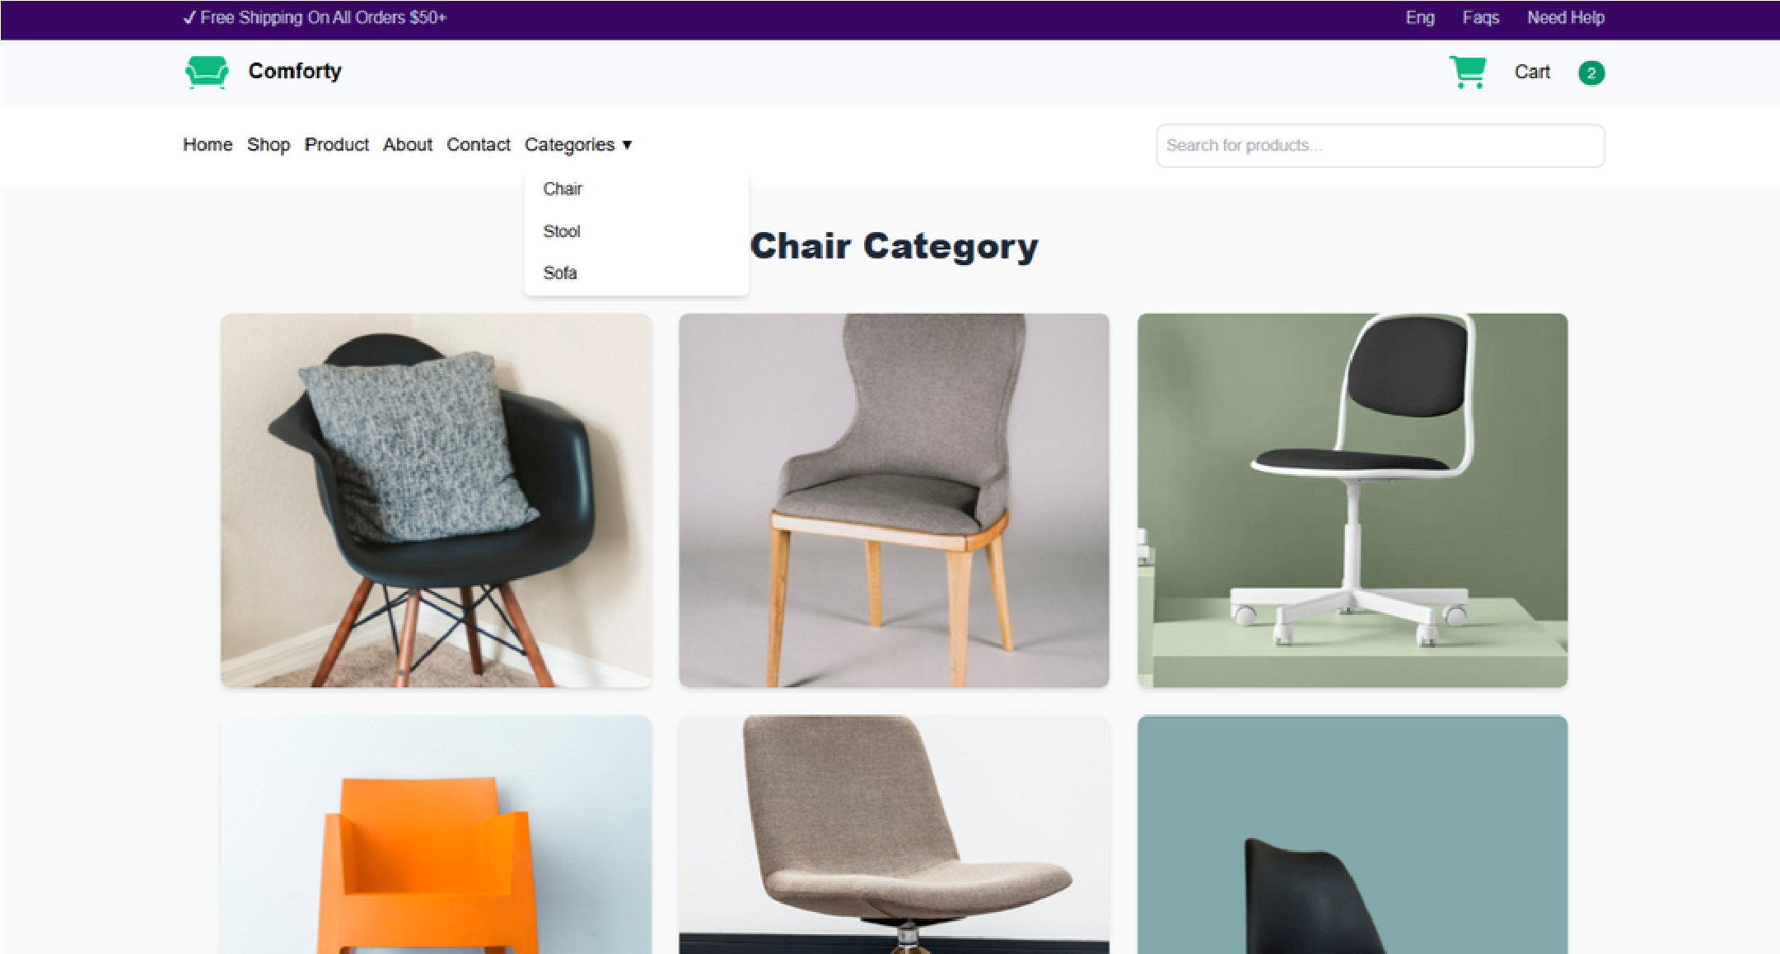

# Who We Serve

**Our target audience includes:**

Homeowners seeking stylish and afordable furniture

O ce managers looking to furnish their workspaces Anyone in need of quality furniture at competitive prices

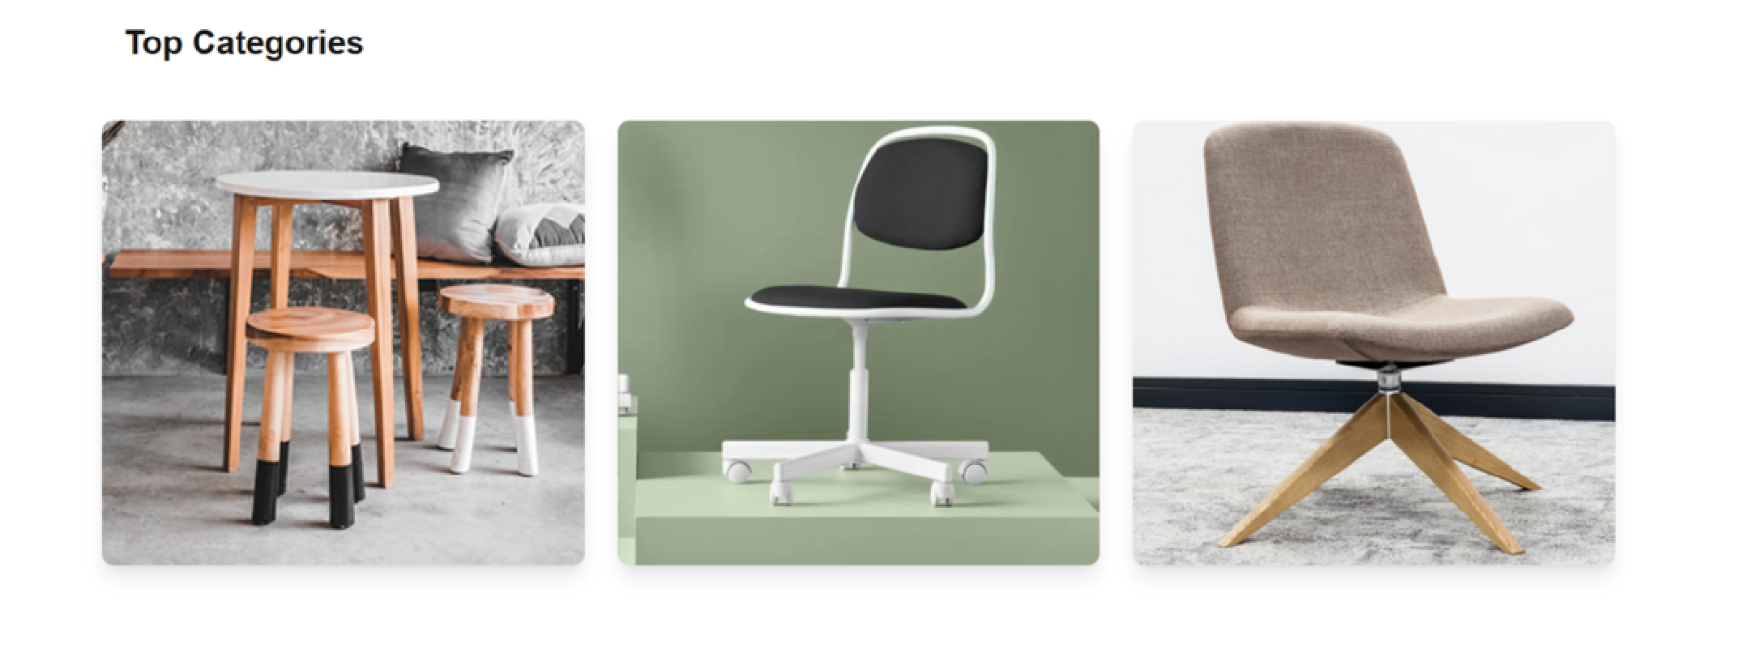

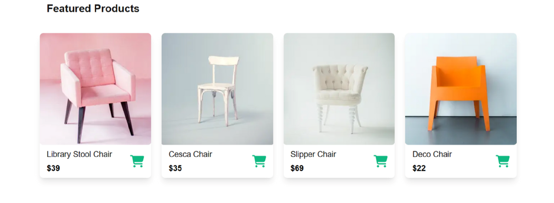

## How Comforty Works

Our business model simplifies the shopping process:

1. Browse our extensive range of furniture
2. Use category search and filters to find the perfect items
3. Add selections to your cart and proceed to checkout
4. Easily manage orders with our backend system powered by Sanity

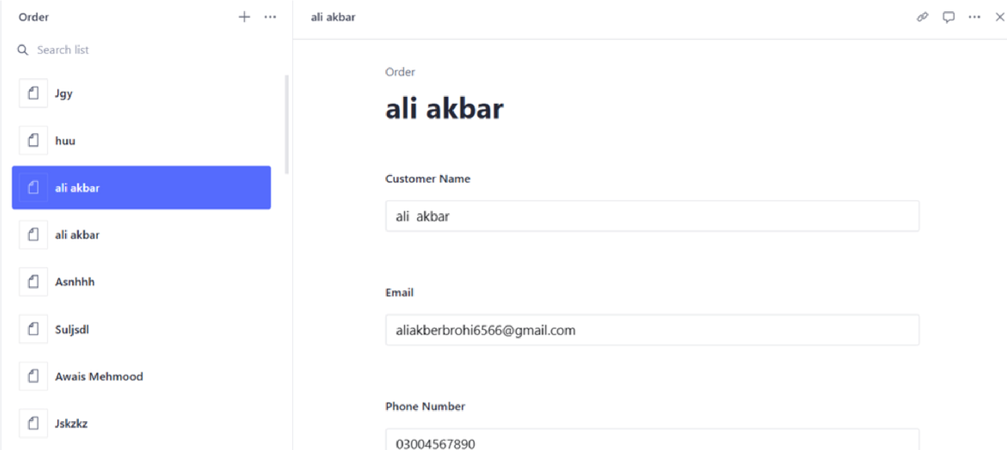

## Why Comforty is the Best Choice for Clients

Choosing Comforty means:

A user-friendly interface for easy shopping

Cost-e active solutions without sacrificing quality The ability to manage and track orders e artlessly

## Ready to Transform Your Furniture Shopping Experience?

Join us at Comforty and revolutionize your furniture shopping experience. Whether for home or once, our platformers a seamless transition from browsing to owning the furniture you need.